Report

Game 1

Description

This is game is about a dice game where two six sided dices are rolled and output will display a message in following format:

* If the sum of two dice are above 7: “Better than 7”
* If the sum of two dice are below 7: “Worse than 7”
* If the sum of two dice are equals to 7: “Exactly 7”

Messages will display.

Solution

First my program displays a message in console whether to run the testcases or run the game.

In testcases:

It just has 3 testcases in the order of assignment given.

First testcase displays whether the sum generated by the two dices are 7 or above 7 or below 7

Second testcase displays whether all the possible test cases are there. That means 36 cases should be there I just displayed it in the console.

I just the random number from two lists which has numbers from 1 to 6, so that no need to check whether a number is between 1 and 6 inclusive.

In third testcase it just runs 36000 testcases, and display the number of occurrences of the sum from 2 to 12.

In Game:

It asks for two inputs that means It displays a message like “Enter 1 to roll the die”

If the user enters 1 then it will display the message related to the sum generated by selecting two random numbers for dice 1 and dice 2.

If the user enters 0 as the input then it will end the game.

Screenshot of output

Testcase 1

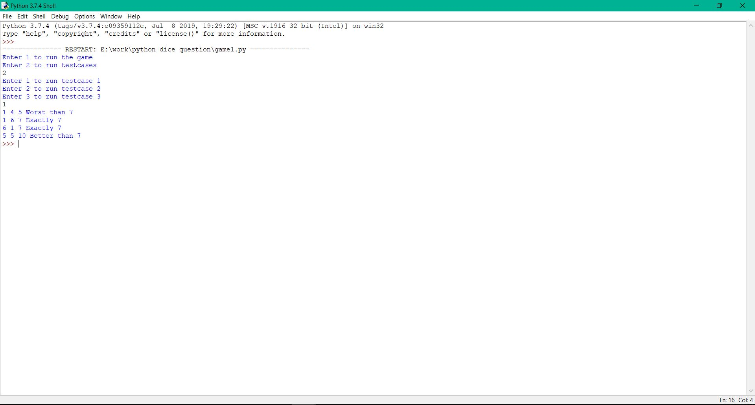

Testcase 2

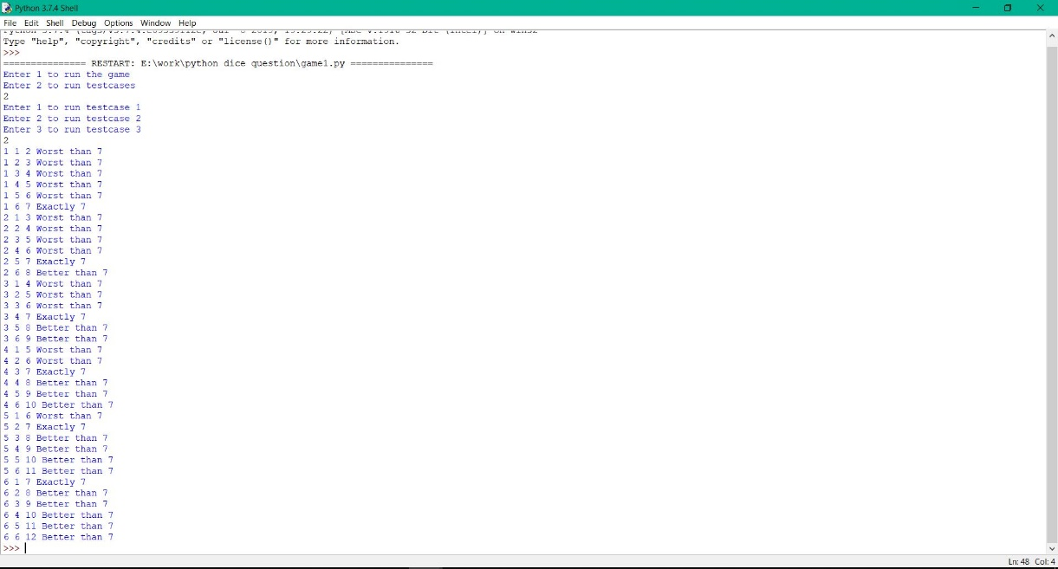

Testcase 3

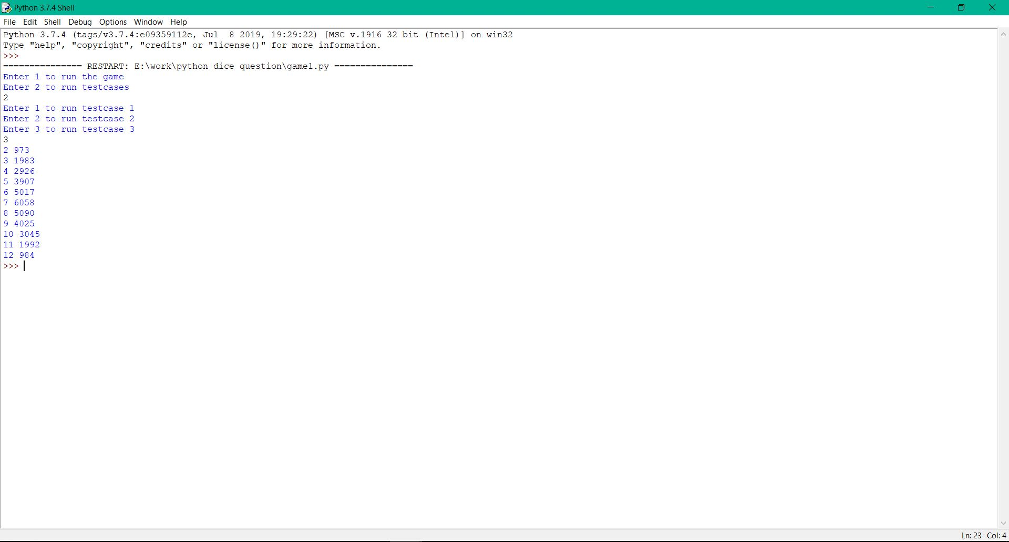

Game Run

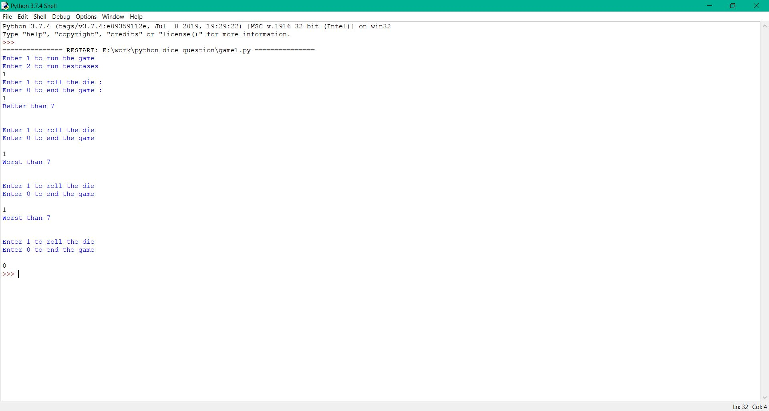

Explanation of how random numbers are selected

Created two lists as list1 and list2 which have elements as [1,2,3,4,5,6]

Using the random library I randomly select a number from the list using random.choice() function.